# Semi-conductors and electronics

Passive devices: Cannot control charge flow by means of electricity

Active devices: Can control charge flow electrically

* Silicon is the dominant *scs,* this is due to the abundance of it’s source material – sand
* A diagram of a structure

  Description automatically generatedOther compounds of III – V elements can also act as *scs*

## Features of semi-conductors

1. Flow of electrons and holes

* Energy can be transported by the presence and absence of electrons
* **A diagram of a band

  Description automatically generated**The absence of e- are called holes
* Current flow refers to the direction flow of +ve charge
* Holes always flow in the opposite direction of e-

1. Reasonable energy gaps

* Bands are groups of energy level
* The band gap is the min *E* required to excite an e-
* The key structure: *scs’s* band gap allows excitation of e- in a reasonable amount of E

1. Allows for doping

* Undoped *scs* are called intrinsic
* We can increase it’s conductivity by adding impurities. This can be done in two ways:

|  |  |  |
| --- | --- | --- |
|  | n-type (-ve) | p-type (+ve) |
| Dopant | V elements | III elements |
| Free majority carrier | e- | Holes |
| Bonds | Extra electrons | Missing electrons |
| Example | For each Si [IV] replaced by P [V], extra e- introduced. | For each Si replaced by B [III]*,* one e- is removed. |

## PN Junction (Diodes)

Diodes only conduct when potential is applied at a certain direction.

Diodes are passive devices.

The circuit symbol points towards the n-type material

### Diode modes

|  |  |
| --- | --- |
| **Forward Bias Mode** (ON)  Current applied forward | **Reverse Bias Mode** (Off)  Current applied in the opposite direction will not flow (open circuit), unless you exceed the maximum reverse voltage that the diode can handle.  This is due to a built-in electric field blocking flow of charge carriers. |

### A diagram of a function Description automatically generatedDiode characteristics

At the forward bias, diodes respect the following relationship:

$$I_{D}=I_{S}⋅e^{\frac{V_{D}}{V_{T}}}$$

* $V_{T} \text{and} I_{S}$*are constants*
* *D represents values for the diode*

At the reverse bias, the diode outputs a constant negative current $I_{S}$

### Logic gates

Diode can only implement AND & OR gates as NOT gates require active devices

## Bipolar Junction Transistors (BJTs)

BJTs are one of the active devices that can control charge flow electrically.

* The emitter region is heavily doped
* The BJT is in active region when $V_{BE}>0 and V_{BC}<0$
$V_{BE}=V_{B}-V_{E}$

* If $V_{B}$ = 0, current does not flow between $C \& E$. Deduce the logic gates constructed by truth table.

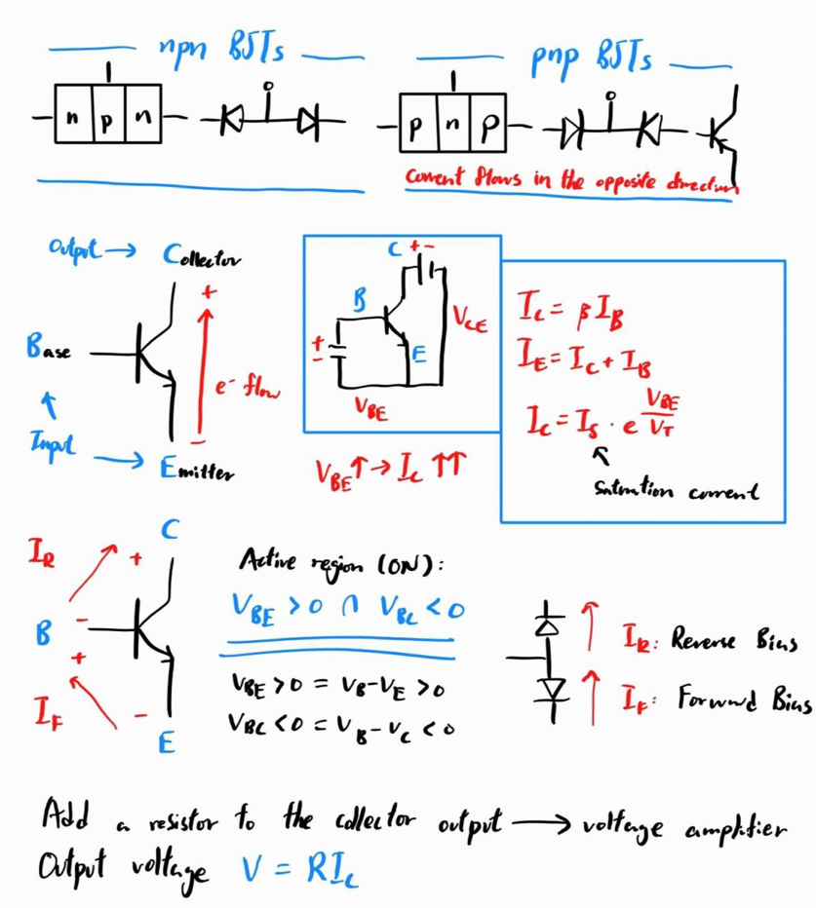

## Capacitors

* Diagram of a type of icon

  Description automatically generated2 conducting plates separated with non-conducting materials
* There’s an electric field between plates, storing energy

### MOS Capacitors

Metal (+ve) – Oxide – Semiconductor (-ve) forming a capacitor.

## MOSFETs

Metal – Oxide – Semiconductor Field Effect Transistors

### n-MOSFET

**How it works** [{Video}](https://www.youtube.com/watch?v=Bfvyj88Hs_o&list=PLfYdTiQCV_p7sDswtLZKK43BWOd2mTmHC&index=15)

1. Positive potential applied at the gate
2. Holes are repelled in the channel region, connecting the 2 n blocks with a depletion region
3. There’s a free flow of e- between the source and drain

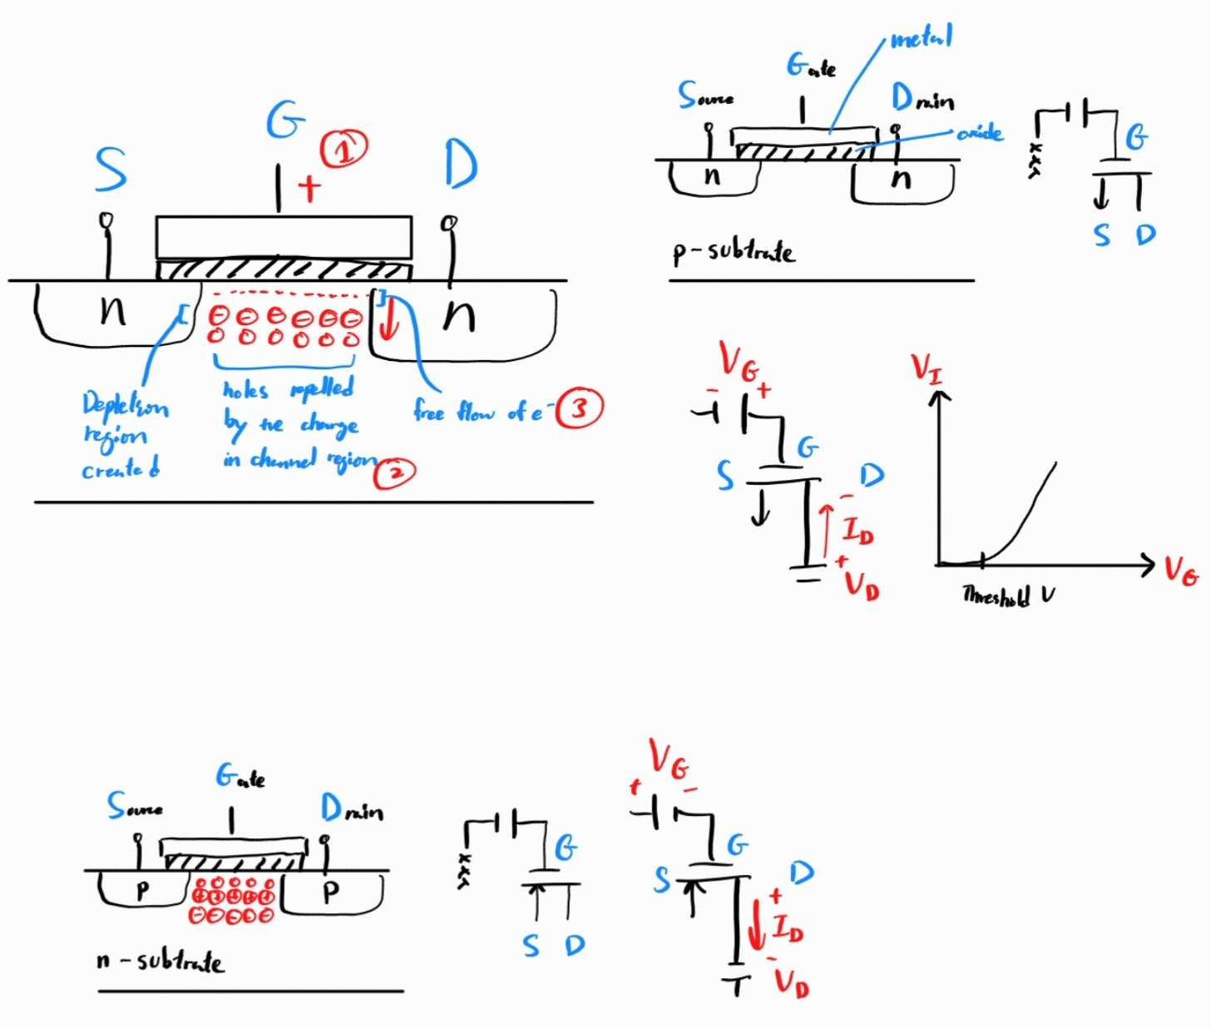

$$I_{D}=\frac{1}{2}μ_{n}C_{ox}{\left(V_{G}-V_{T}\right)}^{2}$$

### p-MOSFET

They work the same as n-MOSFETS, just with holes as charge carriers (current flowing in opposite direction)



### Complementary MOS

* Both n and p type transistors are used
* Used for things like RAM and ROM
* NMOS and PMOS operated in complementary fashion:
  + NMOS turns on when +ve V applied
  + PMOS turns on when -ve V applied

### Comparing BJTs and CMOSFETs

BJTs:

* Higher transconductance $g_{m} (V↑→I↑↑)$

CMOS:

* Lower power consumption
* Higher noise immunity
* Higher switching speeds
* Higher packing density
* Less heat dissipation

## Moore’s Law

Smaller transistors are better because:

* Shorter distance between drain and source
* More power efficient
* Higher transistor density

**Moore’s Law:** The number of transistors in a dense integrated circuit doubles about every 2 years

It is known to **not continue forever** as eventually miniaturization will lead to atomic levels, at that point the law cannot be sustained.

## Optoelectronics

### Optical absorption

1. The excitation of e- from valence band requires a min energy of Eg
2. When e- absorbs a photo with $E>E_{g}$ and excites to the conduction band:

* A free e- created in conduction band, and;
* A hole created in the valence band

Application: Photodetectors and arrays

### Recombination and luminescence

When the created e- and hole recombines, it generates photons (light) or phonons (lattice vibrations)

Application: LEDs

### LEDs

They are a type of diode device

**Electroluminescence**: When e- cross the n-p junction, the e- hole recombination process produces photons, emitting light / IR waves

Ways to change the color of emission:

1. White light + color filters
2. Different emission wavelengths by band gap energy difference (Small gap = High wavelength)

# Communications

Communication is the information transmission between two points, separated in space or time. (Delivery vs. storage)

## Analog communication

* Messages transmitted must be analog
* Slowly rendered obsolete

## Digital communication

* Requires source coding and channel coding

## Modulation

The process of having a baseband signal modify another higher-frequency signal (carrier)

Carrier signal: A high-frequency waveform ($f_{c}$) which used to be modulated for carrying information. They don’t contain any information themselves

### A diagram of a frequency Description automatically generatedSidebands

When a carrier is modulated, sidebands with different frequencies are formed:

* Upper side band: $f_{USB}=f_{c}+f_{m}$
* Lower side band: $f_{LSB}=f_{c}-f_{m}$
* $f_{m}$: Frequency of information signal

### Pulse modulation

Rectangular waves are used to modulate carriers. The signal is transmitted in the form of pulses

### Single sideband (SSB) modulation

* Most transmitted power is used for the carrier, which doesn’t contain any information
* Efficiency is improved when we suppress the carrier and eliminate another sideband, resulting in a SSB signal

**Benefits:**

* Conservation of spectrum space
* More signals can be transmitted in the same frequency range
* Stronger signal (further, more reliable)
* Less noise
* Less selective fading over long distances

**Disadvantages:**

* Harder to demodulate

### Amplitude modulation (AM)

The information signal varies the A of the carrier

### Frequency modulation (FM)

The information signal varies the f of the carrier, holding A constant.

* Modulating signal → FM signal
* Higher A → higher f
* Lower A → lower f
* For binary data: 0 = carrier f, 1 = higher f

**Comparing with AM**

* Noise immunity (fixed A)
* Higher efficiency
* Excessive spectrum use
* Has a complex circuit

## Multiplexing

Simultaneously transmit $≥2$ individual signals over a single channel → increases number of comm. channels → save cost

* Running multiple cables for each channel is expensive, so multiplexing saves cost with more number of channels in a medium
* Multiplexing is done by a multiplexer

### Frequency-division multiplexing (FDM)

Different signals share the bandwidth of a common communication channel

* Different modulators use a slightly different f for their carriers (called a subcarrier)
* The f’s are equally spaced
* The signals are given a portion of the bandwidth
* Any modulation can be used
* Resulting output signal is a composite of all the modulated subcarriers
* To demultiplex, the signal is sent to a group of bandpass filters, passing only its channel and rejecting all others

### A diagram of a signal Description automatically generatedTime-division multiplexing (TDM)

Each signal occupies entire bandwidth, but only for a brief amount of time.

Multiple signals take turns transmitting over the channel.

### Comparing FDM & TDM

|  |  |
| --- | --- |
| FDM | TDM |
| Preferred for analog | Preferred for digital |
| Complex circuitry | Simpler circuitry |
| Possible crosstalk due to imperfect bandpass filters | Crosstalk not severe |
| No propagation delay | Has propagation delay due to timeslots |
| Expensive | Less expensive |

## Optical communication

Uses light to transmit information

* Infrared light is being used
* Medium can either be free space or fiber-optic cable
* Allows very high rates of data transmission with excellent reliability (as frequency of light is high extremely high)
* Using light provides vastly increased bandwidths, using light of different intensity

### Fiber-optic cables

Total internal reflection of light allows them to travel through a cable.

Recap: $θ_{i}>θ_{c}$ (Angle of incidence > Critical angle) → TIR occurs.

$\sin{θ_{c}}=\frac{n_{2}}{n_{1}}, n_{1}\sin{θ_{i}}=n_{2}\sin{θ_{r}}$

* The portion of fiber-optic cable that carries light is made from glass or plastic (Has $n_{1}$ refractive index)
* The wire is contained on outer cladding (Has $n_{2})$
* $n_{2}<n_{1}$ slightly
* A diagram of a diagram of a fiber optic diagram

  Description automatically generatedThe light beam is focused onto an end of the cable, such that repeated TIR occurs within the cable for the light. (A, C, D)
* If the focus angle is too large, refraction occurs instead of TIR (B)

### Wavelength-division multiplexing (WDM)

Basically, FDM but using wavelength to describe such multiplexing for light is preferred.

* Different “colored” lights are used (around 1550-nm range)

### Dispersion in fiber-optic cables

* A red line and blue lines

  Description automatically generatedLight travels in multiple paths in the cable, and the pulse duration is spread out due to delay in light travelling in longest path to reach the end
* If the pulse frequency is too low, one long pulse will occur
* Hence there is an upper limit for pulse repetition rates
* A lower pulse frequency results in being able to handle less information

### Chromatic dispersion

* Happens when multiple wavelengths of light are used
* This is due to the different wavelengths used dispersing and potentially overlapping

### Performance

The pulse frequencies influence an important stat in fiber-optic communication – data rate.

* The best systems use high-power injection laser diodes and APD detectors

# Computer sys, pgmg & networking

## 1 – Abstraction model of computer systems

Abstraction is the process of encapsulating details by well-defined interfaces

This allows us to make use of something even before you fully understand how it works.

### Decomposition of complex systems

**Decompose**: Each sub-system can be decomposed into more sub-systems

**Compose**: Each composed system can be used to compose bigger systems

This organization forms a hierarchy

### Electronic systems

**Input**: Physical quantity 🡪 Internal quantity

* + - * + Electrical signals
        + Voltage
        + Current…

**Process**: Perform the intended function of the system, not necessary to know about the rest of the system

**Output**: Internal quantity 🡪 Physical quantity

* + Sound
  + Temperature
  + Light…

### Layers of a computer system

1. Diagram of a diagram of software

   Description automatically generated**Hardware architecture**

Hardware, logic gates

1. **Operating system**

Linux, Windows, MacOS

1. **Application software**

## A diagram of a central processing unit Description automatically generated2 – Computer Organization

1. CPU
2. Memory Unit
3. Input devices
4. Output devices
5. Storage devices

### Central Processing Unit (CPU)

Controls the operation of all parts of the computer system

#### Arithmetic and Logic Unit (ALU)

Carries out operations needed by the processor

* Arithmetic: $+- × ÷$
* Bit operations: Shift, AND / OR
* Comparison: $< > ≤ ≥ = ≠$

#### Control Unit

Determines what to do based on instruction and previous computation

* ALU’s function based on given instructions
* The read/write of memory
* The reset of the data path

#### Registers

Stores small amounts of data

* Current instructions
* Address of next instruction
* Results of calculations

### Memory

Stores instructions and data. The instructions control the operation of the CPU

#### Main memory

* **Volatile** – stored information is lost if the electric power is removed
* **Direct access** – information can be reached directly
* RAM – Random Access Memory (User programs)
* ROM – Read-Only Memory (OS)

#### Cache memory

* Modern systems have layers of cache memory
* High performance with low access latency (lower layers have less latency)

### Stored Program Computers (von Neumann)

They have the von Neumann architecture (Stored Program Architecture)

* Stores both program instruction and data in the same memory storage
* Performs computation by executing instructions stored in the memory

#### Advantages

* Data and instructions are accessed the same way everywhere, from the memory unit or external devices

#### Disadvantages

* The performance bottleneck is the speed of memory access
* CPU is idle while memory is being accessed

### Classes of computers

* Same fundamental principle of operation
* Different design optimization and tradeoffs

1. **Desktop**

Laptops, PC, tablet, smart phones

1. **Server**

* Modern servers have highly parallel multiprocessor systems
* Usually accessed only through networks
* Datacenter, web streaming

1. **Embedded System**

Computer systems as components

* Performs simple, dedicated functions
* Limited resources (power, memory, storage etc.)
* Navigator, camera

### Power consumption

Power consumption is a major concern for all classes of computers, as it is proportional to performance

The technical challenge is finding ways to improve performance without significant increase to power

### Performance

Factors affecting the performance of a computer:

1. **CPU clock speed**

The number of instructions that can be performed per unit time

1. **Bus speed**

The time for data transfer between CPU and memory

1. **Memory-access speed**

Latest technologies in computer systems to improve performance:

1. **Parallel processing**

Using multi-core CPUs to parallelly compute, increasing performance

More cost is the price for less time

1. **Graphic Processing Unit (GPU)**

They have a massively parallel architecture with thousands of efficient cores

Commonly, around 5% of compute-intensive tasks of the application is off-loaded to the GPU for performance gain. The rest of the code runs on the CPU

1. **Edge Computing (EC)**

EC keeps data close to users to reduce the delay of waiting for any server response in cloud computing

## 3 – System software

Types of system software:

1. **Operating Systems**

* Manage resources
* Controls all machine activities
* Provides the user interface

1. **Compilers / Interpreters**

* Translates high-level programming language 🡪 low-level machine instructions
* Compiler: Translate whole program at once before execution
* Interpreter: Translate program while it’s running
* High level programming language: Human- interpretable language
* Low level machine instructions: Machine oriented

### A diagram of a diagram Description automatically generatedRunning a computer program

The CPU continuously follow the **fetch-decode-execute** cycle:

1. CU fetches instruction from main memory
2. CU decodes, moves data from main memory $→$ ALU
3. ALU executes instructions

## 4 – Computer networking

Types of computer network:

1. **LAN Local Area Networks**
2. **WAN Wide Area Networks**

# Data, logic gates & binary computation

## Data representations

* **Analog data:** Continuous data that can be changing over time
* **Digital data:** Discrete data that are broken up and can only take specific values

### Digital abstraction

The act of representation of signals as two discrete values [(1,0), (TRUE, FALSE)] etc.

### Analog to Digital Conversion

* **Sampling:** Recording analog signal at regular time intervals
* **Quantization:** Mapping each analog value to a finite set of digital values (1,0)
* An **ADC** performs both sampling and quantization
* **DAC** converts digital signals back to analog signals
* 1 and 0s are represented by different levels of voltages
* **Quantization error:** Difference between original sampled value and rounded value
* **Disadvantage:** Converting analog to digital introduces loss of information

### Advantages of using digital representation

1. Boolean algebra can be used for effective analyzation by
2. Ease to build large system with hierarchy
3. Lossless manipulation of data
4. Resistant to noise
5. Finite values, more manageable to compute
6. Lossless transmission of data

## Binary representations

* A bit can only hold 1 or 0, corresponding to a high voltage or low voltage.
* Most computers adopt the binary representation

### Converting bases

#### Converting numbers to base 10

Multiply each digit starting from the right by $B^{p}$, where $B$ is the base of the number and $p$ is the 0-starting position of the digit

Example: $10110=2^{4}+2^{2}+2^{1}=18$

#### Converting base 10 numbers to another base

Short division (stop when base is larger than remainder), then concatenate the remainders together to from the number.

Example: ${333}_{10}=14D_{16}$

#### Converting between binary and hexadecimal

Each group of 4 bits form one digit in hex representation

Example: $0010 1010 {0011}_{2}=2A3_{16}$

### Negative binary numbers

|  |  |
| --- | --- |
| Sign-magnitude representation Change leftmost digit of positive number in binary to 1 | One’s complement Invert bits of positive number in binary |
| BOTH representations has 2 zeros (+0 and -0) | |

#### Two’s complement

Invert bits of positive number in binary, then add 1

Example: $2_{10}→{0010}_{2}\underset{→}{\text{Invert bits}}{1101}_{2}+1→{1110}_{2} (-2_{10})$

## Logic gates

|  |  |  |  |  |
| --- | --- | --- | --- | --- |
| Logic function | Abstract | Symbol | Truth table | Boolean expression |
| NOT | Invert input |  |  | $$y=\overline{a}$$ |
| AND | Both input 1 | $$y=a⋅b=ab$$ |
| NAND | Not both input 1 | $$y=\overline{a⋅b}$$ |
| OR | Either input 1 | $$y=a+b$$ |
| NOR | Not either input 1 | $$y=\overline{a+b}$$ |
| XOR | Only either input 1 | $$y=a⊕b$$ |
| XNOR | Not only either input 1 | $$y=\overline{a⊕b}$$ |

### Precedence

BNAO: $()→NOT→AND→OR$

$\overline{a+b}=\overline{\left(a+b\right)}→(a+b)$ first before applying NOT

### Combinational functions

A function is combinational if they:

1. No loops are present in the connection
2. Only 1 output connected by an input
3. All enclosed functions are combinational

## Binary computation

### Subtraction

Using two’s complement, we add the negative number to the positive number: $A-B=A+(-B)$, utilizing the existing addition function in the ALU

### Floating point numbers

$Value=s⋅2^{-e}$ where $s=$ significant, $e=$ exponent

Example: $010 | 00110101→{110101}_{2}⋅2^{-{010}_{2}}={53}_{10}÷4_{10}={13.25}_{10}$

#### IEEE Floating Point Number

The standard way to represent floating point numbers

* 32-bit length
* Most significant bit (MSB) is the sign bit
* A green rectangular object with black text

  Description automatically generated8-bit exponent
* 23-bit significand (value)

# Modern CE applications

## Artificial intelligence

AI refers to the simulation of intelligent behavior in computers. That is, to help machines understand the world, and react to situations in ways like how humans do.

*To overcome challenges in the real world, the AI must be able to:*

1. Efficiently handle large amounts of data
2. Process data simultaneously from multiple sources
3. Organize data in a way that allows us to derive insights
4. Learn from new data and update constantly
5. Think and respond to situations based on conditions in real time

*There are multiple fields that AI can be applied to:*

1. **Machine learning and pattern recognition**

Software designed to learn from data

1. **Logic-based**

Set of statement in logical form expressing facts and rules about a particular problem domain

1. **Search**

Examine large number of possible and pick the optimal path

1. **Knowledge representation**
2. **Genetic algorithms / programming**

### Machine learning

Uses algorithms to learn patterns from the previous data $→$ make future predictions or classify new data

1. **Supervised learning**

Training on a labeled data set

1. **Unsupervised learning**

Training on an unlabeled data set

1. **Reinforcement learning**

Training by trial-and-error with given rewards

1. **Deep learning**

Machine learning with a neural network with many layers

## Internet of things

IoT refers to physical objects with sensors and other technologies that connect and exchange data with other devices and systems over a communication network

*There are 2 enabling technologies for IoT:*

1. Computing technology
2. Networking technology

# Fundamentals of electricity

## Basics

* Atoms have same number of protons and electrons
* Atomic number $Z=p+n$
* Valance e-: e- of outermost orbit, they have the smallest attraction from nucleus
* Free e- flow are the basis of current electricity
* Conductors have plenty of e- but insulators have very few
* e- flow direction is opposite to current flow direction

## A line graph with a line and a arrow Description automatically generated with medium confidenceTypes of current flow

### Direct current

DC: e- travelling continuously in a direction

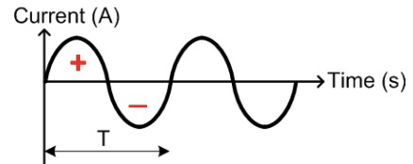Constant DC: The amount of e- travelling is constant

Time-varying DC: The amount of e- travelling varies with time

### Alternating current

AC: e- travels in alternating directions

Sinusoidal AC: $I\left(t\right)=I_{Peak}×\sin{2πft}$



$I_{rms}=\frac{I_{peak}}{\sqrt{2}}$

Square-pulsed AC:

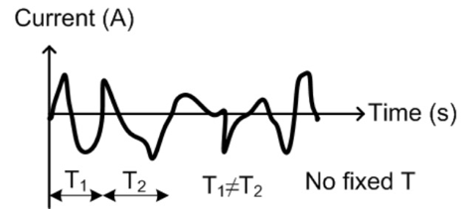Aperiodic amplitude-varying AC:

## Electric circuit

* Current must be driven by the EMF with a voltage
$E=QV$

$V=IR$

$P=\frac{E}{t}=IV=I^{2}R=\frac{V^{2}}{R}$

* Faraday’s law: $V_{emf}=-\frac{ΔB_{flux}}{Δt}=-\frac{d}{dt}B_{flux}, B_{flux} \text{is the magnetic flux}$
* A cell / battery does not provide the charge, only the Voltage
* The charge carriers are supplied by the conductor
* Net charge on a conductor is 0
* Current in Engineering revers to current flow
* The voltage / current rated values are expressed in RMS values

# Resistor, Inductor, Capacitor & Circuits

## A table with different colors Description automatically generatedResistors

$$R=\frac{ρL}{A}$$

They are used for:

1. Limiting current in electric circuits
2. Lowering voltage levels
3. Provide currents
4. Sensors

* Resistors are rated in Watts, which defines it’s upper power limit and shouldn’t be violated
* A higher power-rated resistor can dissipate more power
* A diagram of a line of colored lines

  Description automatically generated with medium confidenceResistors are color coded:

$$R=A⋅B⋅C\left[\text{multiplier}\right]⋅\left(1±tol\right)$$

## Circuits

$$V_{t}=IR_{t}$$

Voltage is split between components by: $V_{comp}=I*\frac{R_{comp}}{R_{t}}$

Distribution in series:

* Current: Same
* Potential difference: $\sum{V}=emf$

Distribution parallel:

* Current: $\sum{I}=I_{total}$
* Potential difference: Same (across branches)

### Resistances

* In series: $R_{t}=\sum{R}$
* Parallel:

We can use star to delta transformation to solve question related to resistors in series:

### A close-up of a diagram Description automatically generatedCells

Cell emf stacks. One cell provides $1.5V$

## Electric field

Uniform: $E=\frac{V}{d}$

Radial: $E=\frac{Q}{4πε_{0}d^{2}}$

## Capacitors

They have two parallel plates that are separated by a dielectric insulating layer, of which no current can flow through the capacitor.

Capacitor charges up to the emf, and maintains it as long as the supply voltage is present.

The e-field between the plates are uniform

Functionality:

* Stores energy
* Coupling AC signal and decoupling DC signal
* Filter noise in signal

Capacitance $C (F)=\frac{Q}{V}=\frac{It}{IR}$

Energy stored $E (J)=\frac{1}{2}CV^{2}$

* In series: $C_{t}={\left(\sum{C^{-1}}\right)}^{-1}$
* Parallel: $C_{t}=\sum{C}$

### Polarized Capacitors

The +ve terminal of capacitor must be connected to the +ve terminal of emf. They are used in DC circuits.

### A diagram of a sine wave Description automatically generatedIn AC circuits

* The capacitor is charged, discharged and charged in the opposite direction at the same rate as the AC supply voltage.
* Current always leads voltage by ¼ of a cycle due to the capacitor’s charging state.

## Inductors

They are devices which stores energy in the form of magnetic flux when a current passes through it.

They have a wire tightly wrapped around a central core that is either a rod or a ring.

Current output is the reverse of capacitor, that the voltage is at negative maxima when not charged

Functionality:

* Stores energy
* Block AC signal but bypasses DC signal
* Filter noise in signal

Inductance $L \left(H\right)$

Energy stored $E \left(J\right)=\frac{1}{2}LI^{2}$

* In series: $L_{t}=\sum{L}$
* In parallel: $L_{t}={\left(\sum{L^{-1}}\right)}^{-1}$

### In AC circuits

* A graph of sine and trigonometry

  Description automatically generatedCurrent always lags voltage by ¼ of a cycle due to it being the capacitor’s reverse

# Electric Power Systems

Responsible for the generation, transmission, and distribution of electrical power efficiently

## The traditional electric utility model

**Properties:**

* Monopoly: Only supplier of electricity in a region
* Vertically integrated: A single organization performs all functions

**Issues:**

* Lack of transparency
* Poor internal communication

## Utility frequency

* **Alternating Current** used

AC allows use of transformers, which can move power between circuits 🡪 efficient transmission

* **50Hz** and **60Hz** AC frequencies are used
  + Low $f$ used because higher frequencies cause power loss
  + Light flickering occurs if $f$ too low

## Energy production

|  |  |  |  |
| --- | --- | --- | --- |
| Energy source | Renewable | Pollution | Limitation |
| Coal | N | GH gas |  |
| Gas | N | GH gas (less) |  |
| Nuclear | N | N | Nuclear waste needs to be carefully handled |
| Hydroelectric | Y | N | Loc (high altitude) |
| Wind | Y | N | Loc (windy), uncertainty by wind |
| Solar | Y | N | Daytime, open space, uncertainty by cloud |

## Solar power

Thermal energy 🡪 Kinetic energy 🡪 Electrical power

Concentrated solar power: Uses mirrors to concentrate large area of sunlight to small area.

A solar panel is made up of PV cells, interconnected in a sealed, weatherproof panel. To convert DC to AC, grid-tied inverters are used.

## Efficiency of the larger picture

$$η_{gen→consumption}=η_{combustion}×η_{turbine}×η_{generator}×η_{grid}×η_{applicance}$$

## Transmission of power

* Power transmitted from power plants to distribution substations
* Gen 🡪 Substation: Transmission network
* Substation 🡪 Customers: Distribution network
* TN + DN: Power grid

### Power loss

Power lines are used to transmit electricity over a long distance, so the resistance is not negligible

Recap: $P=IV, V=IR$

Power generated $P_{V}$

Power delivered $P_{R}$

Power loss to cable $P_{C}=I^{2}R_{c}=P_{V}-P_{R}$

Efficiency $E=\frac{P_{R}}{P_{V}}$

**Solution:**

1. We can reduce power loss by reducing $I$ because $I^{2}$ has the most significant effect.
2. $I∝V^{-1}$ therefore, solution is high voltage transmission

### A diagram of cost and cost Description automatically generatedHVAC vs HVDC

HVAC: High voltage three-phase AC

* Can be easily stepped up and down

HVDC: High voltage DC

* Primarily for long distances
* Lower power loss (compared to AC same current)
* Fewer conductors needed (2<3) per circuit
* Power line towers can be smaller 🡪 Cheaper
* Converter stations (DC to AC) are much more expensive
* Break-even distance is where HVDC cheaper than AC:

Overhead: 600km

Underwater: 50km

* HVDC makes interconnection of two power grids of different $f$ possible

### Transmission line types

**Overhead cables**:

* The power lines must satisfy many requirements:

1. Minimum power loss
2. Safe distance from ground
3. Structure must be strong enough

* Aluminum is preferred instead of copper for long distances. This is because it’s cheaper and lighter, which at long distances outweighs its lower conductivity

**Underground cables:**

* Higher initial cost, but lower operational cost
* Space saving
* Less subject to damage
* Decreased risk of fire
* Less danger from illegal operations (connections, sabotage)

## Distribution systems

Primary: 3 phased, 3 wire systems Feeders supply V to distribution transformers (step down V)

Secondary: 4 phased, 4 wire systems Voltage to consumers

### Diagram of a diagram of a peak Description automatically generatedPower utilization at client

### A diagram of electrical wiring Description automatically generatedBalanced Three Phase System

Peak voltage $u=\sqrt{2}⋅U⋅\sin\left(2πft-θ\right)$

Line to neutral voltage $U=\sqrt{3}⋅V_{supplied}$

$$u_{x}=\sqrt{2}U\sin\left(wt-120°×find\left(\left[A,B,C\right],x\right)\right)$$

**Y connection:**

$I_{a}=I_{A}$ (Phase current = line current)

Line voltage: $V_{AB,BC,CA→x}=\sqrt{3}V_{x}\left(∠\left(-30°\right) \right)$

*Each phase voltage $V_{x}=Vcos\left(wt+x°\right)$ must be separated by 120*

**△ connection:**

$U_{A}=U_{AB}$ (Phase voltage = line voltage)

Phase current: $I_{AB,BC,CA→x}=\frac{U_{xx}}{R}$

Line current: $I_{x}=\sqrt{3}I_{xx}∠\left(-30°\right)$

## Substations

* They have transformers, switches, circuit breakers etc.
* They change $V$ levels at T-D or T-T interconnections
* Power flows through several substation at different $V$ levels between gen and consumption

Switches: Allows substation to be connected or disconnected from electrical network

Circuit breakers: Stop $I$ flow if too high (short circuit / excess demand)

Transformers: Step up or down AC voltage levels

## Operation of transformers

Primary (input) coil: connected to AC voltage supply

Secondary (output) coil: connected to load

Mechanic: Primary coil varying $I$ provides varying mag-field, inducing EMF (voltage) in output coil

* Power can be transferred between two coils without a metallic connection
* Works only with AC not DC
* Transformer turn’s ratio $N=\frac{n_{p}}{n_{s}}=\frac{V_{p}}{V_{s}}=\frac{I_{s}}{I_{p}}$
* ­­The above assume an idea transformer with no power loss: $P_{p}=P_{s}$

### Step-up / Step-down

Step-up: $N_{s}>N_{p}$

Step-down: $N_{s}<N_{p}$

## Reliability of electric system

#### Adequacy (Long term)

The ability to always supply the demand and requirements of the customers, taking account into both schedule and unscheduled outages of system elements.

#### Firmness (Medium term)

Enough supply infrastructure is available when needed, depending onto the operation planning activities of already installed capacity

#### Security (Short term)

The ability to withstand sudden disturbances such as short circuits, loss of system elements or natural damages

### Reliability assessment

Total time a unit is out of service $T_{out}$

Total time a unit is expected to serve $T_{total}$

Forced outage rate: $FOR=\frac{T_{out}}{T_{total}}$

Availability of a unit $AV=1-FOR$

Loss of load expectation (LOLE) is the time (d or h) in a year that a power system is expected not to satisfy the demand

Loss of load probability (LOLP) is the probability of a power system not able to satisfy the demand

$$LOLP=\frac{LOLE}{365d \text{or} 8760hrs}$$

$LOLP$ can also be related to $FOR:$

1. Using the demand of power, find if the unit’s failure would cause a loss of load
2. Calculate the probably using AND OR conditions

# Renewable Energy Systems

## Wind energy systems

#### Advantages

1. Clean source of energy
2. Domestic energy
3. Low priced
4. Use small amount of land

#### Disadvantages

1. High initial investment
2. High uncertainty
3. Noise and visual impact

### Wind

Variability:

* Spatial: Different places have different magnitudes of winds
* Temporal: Different times have different magnitudes of winds

Measurements of wind:

* Ecological indicators: Observe objects like trees and sand
* Anemometers: Measure wind speed and / or pressure when fixed on tall masts

### Wind turbines

#### HWAT

* Capture winds from both forward and backwards at high efficiency
* Flexible rotor blades could shorten their lifespan

#### VAWT

* Harness wind from any direction
* Structure can be not as solid due to the viability to have heavy components on the ground
* Must less efficient

## Photovoltaic systems

A system that directly converts light energy into electrical energy, by utilizing the PV effect of the semiconductor interface

#### Disadvantages

1. Uncertainty on sun
2. Require use of battery
3. High initial investment

### How it works

1. Photons from sunlight absorbed by cell
2. New electron-hole pairs created in cell
3. Pairs separate due to internal electric field
4. Potential difference created 🡪 current

### Standalone PV system

Systems powered only by solar energy

### Grid-connected PV system

Challenges in high-level PV penetration:

* Feeder
* Communication
* Cybersecurity
* Control
* Regulation
* Technology

### Solar cells

Temperature ↑ P, V ↓

Irradiance ↑ P, I ↑

* A series of solar cells can only allow the minimum current of the cells to past through (e.g. one blocked by shade → irradiance ↓)